DA Assignment 3

Haitao Zhou HAZ59@pitt.edu

Github: htz92111

Yingzhi Yang [YIY50@pitt.edu](mailto:YIY50@pitt.edu)

Github: HenryYang0914

Xin Jin [XIJ21@pitt.edu](mailto:XIJ21@pitt.edu)

Github: navis09

House Votes Manual Model

Accuracy:

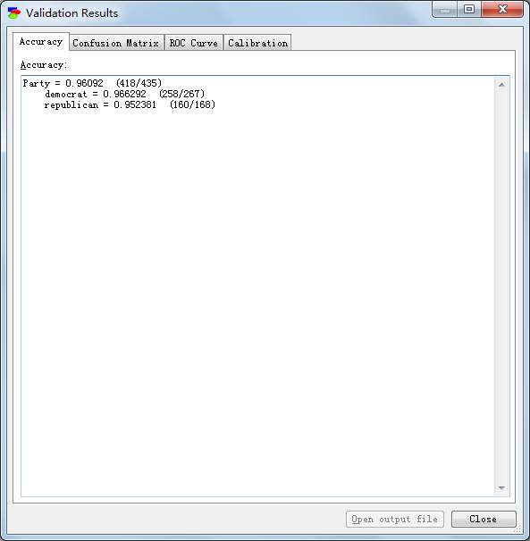

Sensitivity and specificity:

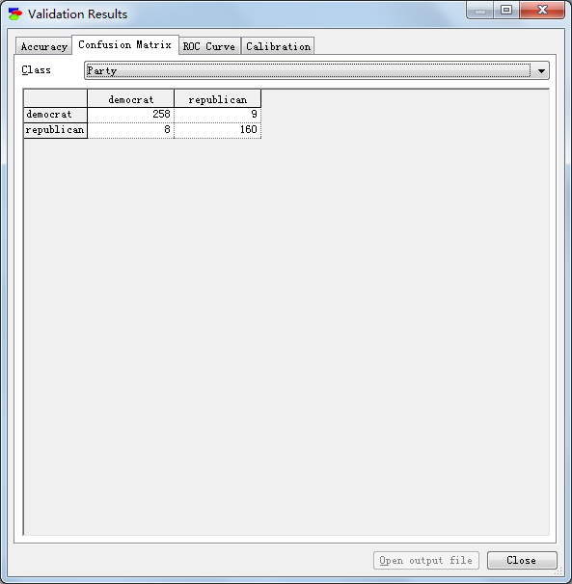

Sensitivity: 258/(258+8) = 97%

Specificity: 160/(160+9) = 94.7%

Positive predictive value: 258/(258+9) = 96.6%

Negative predictive value: 160/(8+160) = 95.2%

Calibration curve:

Democrat:

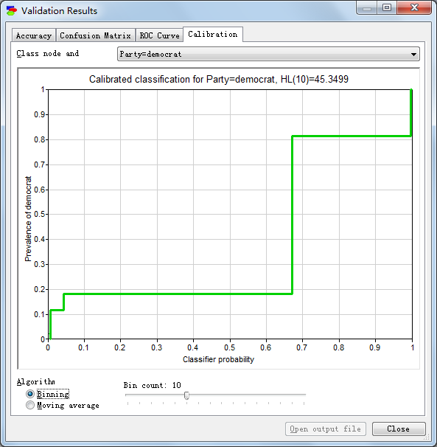

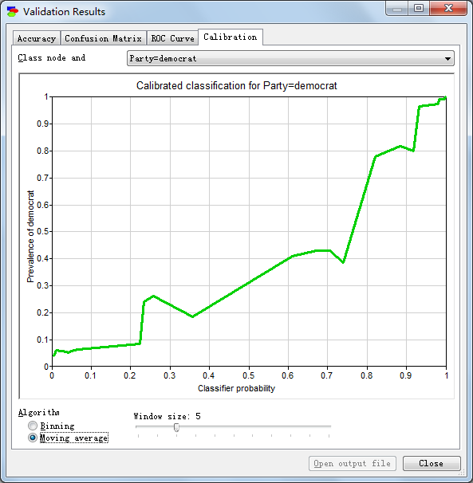

Republican:

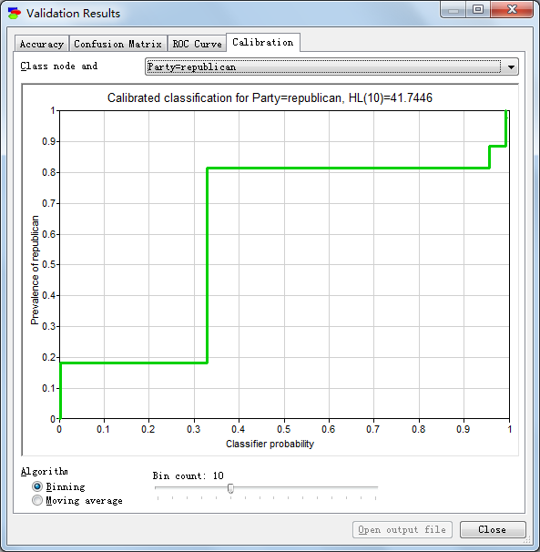

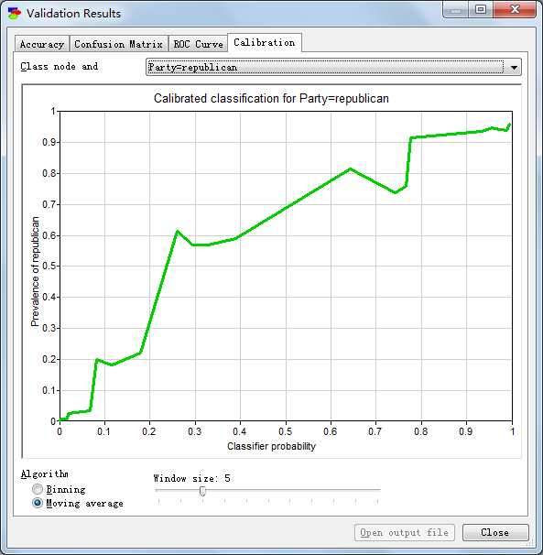

House Vote Naïve Model:

Accuracy:

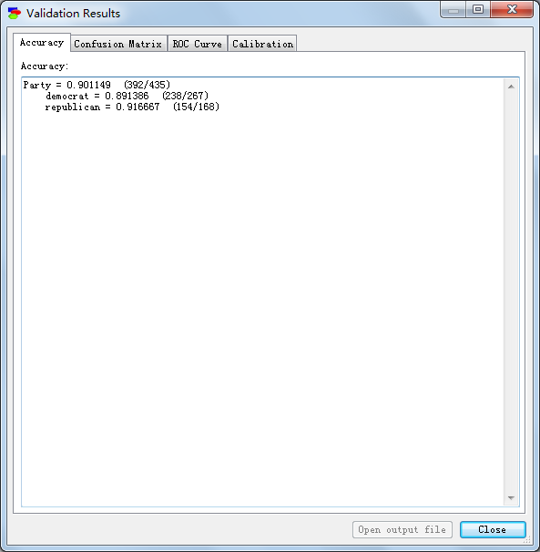

Sensitivity and Specificity:

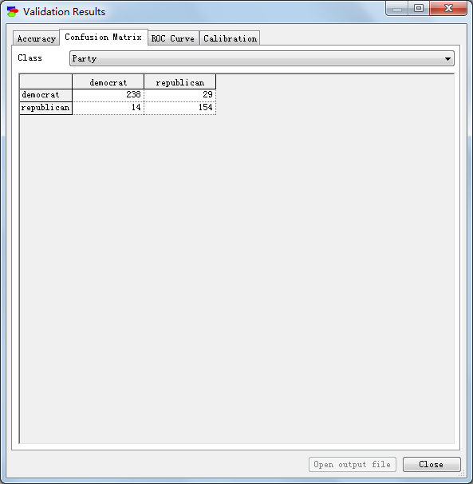

Sensitivity: 238/(14+238) = 94.4%

Specificity: 154/(154+29) = 84.2%

Positive predictive value: 238/(238+29) = 89.1%

Negative predictive value: 154/(154+14) = 91.7%

Calibration curve:

Democrat:

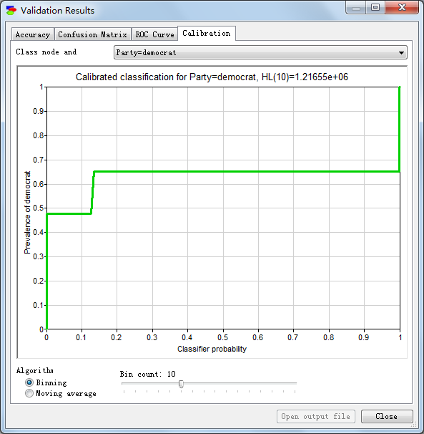

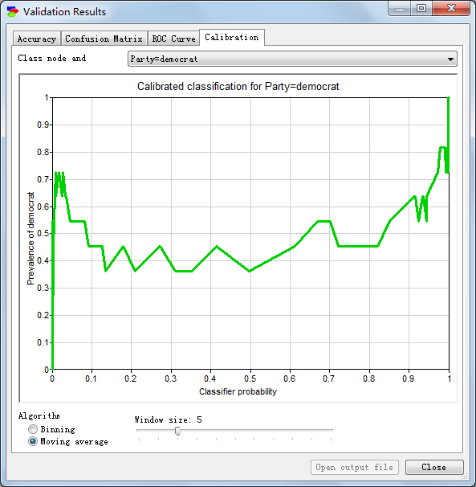

Republican:

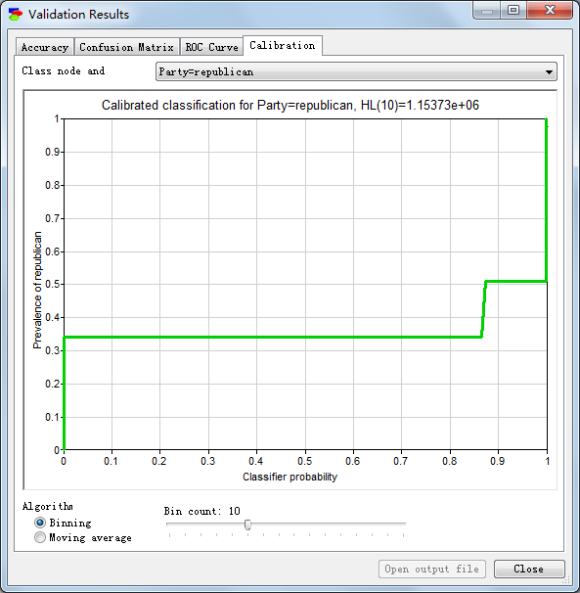

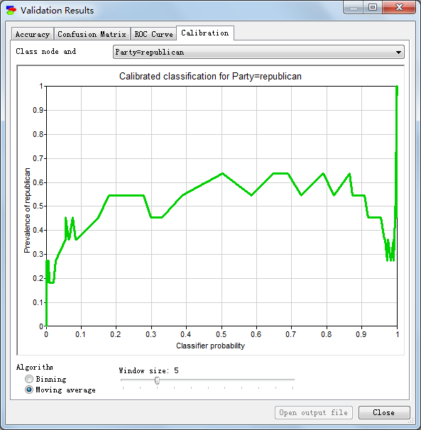

Home Vote PC Model:

Accuracy:

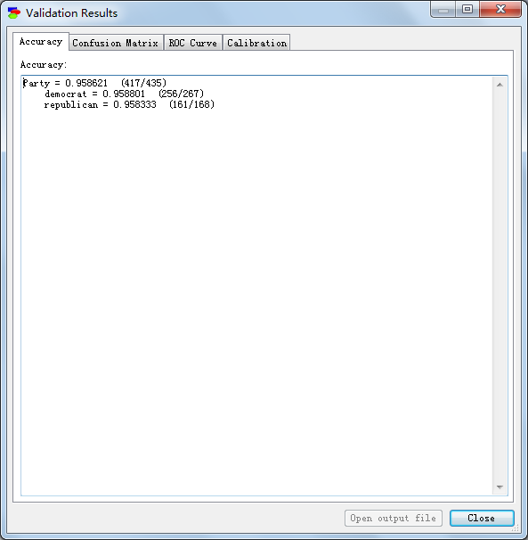

Sensitivity and specificity:

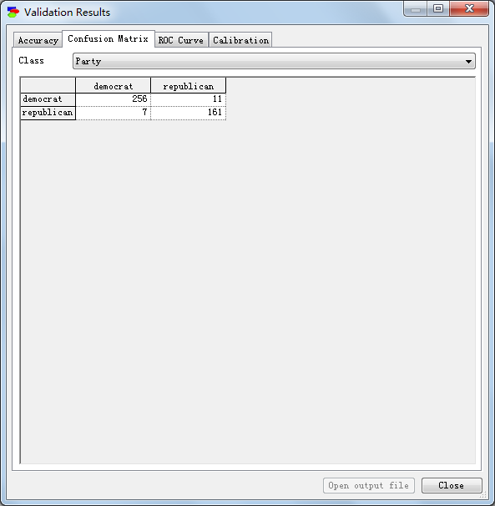

Sensitivity: 256/(256+7) = 97.3%

Specificity: 161/(161+11) = 93.6%

Positive predictive value: 256/(256+11) = 95.9%

Negative predictive value: 161/(161+7) = 95.8%

Calibration curve:

Democrat:

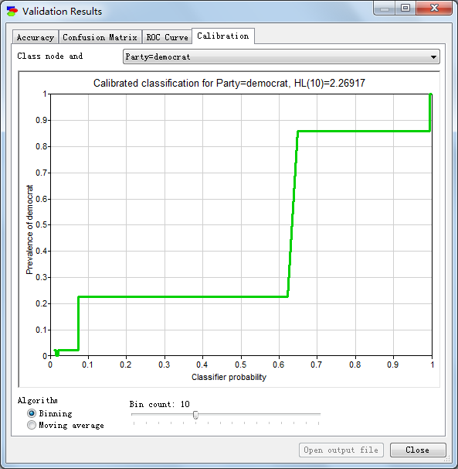

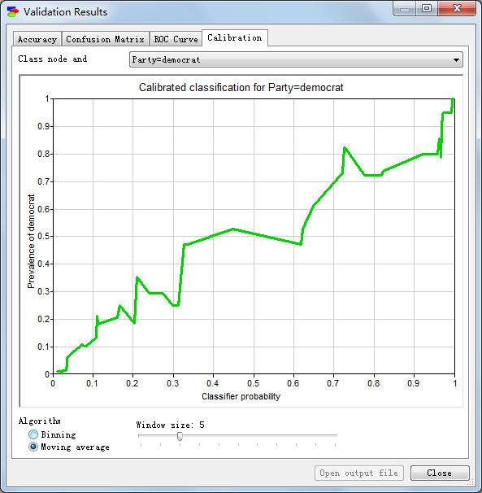

Republican:

